Here I am going to list the steps performed to set up the raspberry PI along with it’s camera and humidity / temperature module to collect the data about lettuce plant growth.

1. Install the OS on the new raspberry pi. For this project we are using the third version of the hardware. Better to install the newest OS which is the 12 Bookworm. The easiest way is to download the Raspberry Pi imager <https://www.raspberrypi.com/software/> to the computer which in its turn will download and install the image of the latest version on the SD card which then will be plugged into berry.
2. Find some screen and keyboard with mouse. They are essential to do at least the very first set up of the berry machine. Following the instructions of the OS installation just complete them.
3. Connect to your laptop to the berry machine via Ethernet cable to use it as an input/output interface. It will be a future alternative to work with the Berry machine and forget about connecting mouse, monitor and keyboard each time.
   1. Install VNC viewer on your laptop.
   2. Check the static IP address assigned to your laptop by typing *View Network Connections* and double click on the ethernet connection. You will find your IPv4 Address in the format of 192.168.137.1
   3. Adjust the IP address and subnet mask on Berry to match my laptop network communication.   
      *sudo nmcli connection show # shows all connections, choose the ethernet one*

*sudo nmcli connection modify "Wired connection 1" ipv4.method manual ipv4.addresses 192.168.137.2/24 ipv4.gateway 192.168.137.1*

*sudo nmcli connection up "Wired connection 1"*

*sudo nmcli connection show "Wired connection 1"*

* 1. Insert the IPv4 address in the bar of VNC viewer, it will ask you for the user and password from berry

1. Connect the camera module 3 <https://www.raspberrypi.com/products/camera-module-3/> and test in the CMD with the commands
   1. *rpicam-hello* – that is a renamed version of libcamera which was supported up to the Bullseye 11
   2. *libcam-hello* – previously supported

<https://www.raspberrypi.com/documentation/computers/camera_software.html>

1. Connect the DHT11 sensor to raspberry pi <https://newbiely.com/tutorials/raspberry-pi/raspberry-pi-dht11> . Remember the board number which you used to connect the output signal. Follow the raspberry pi ports diagram

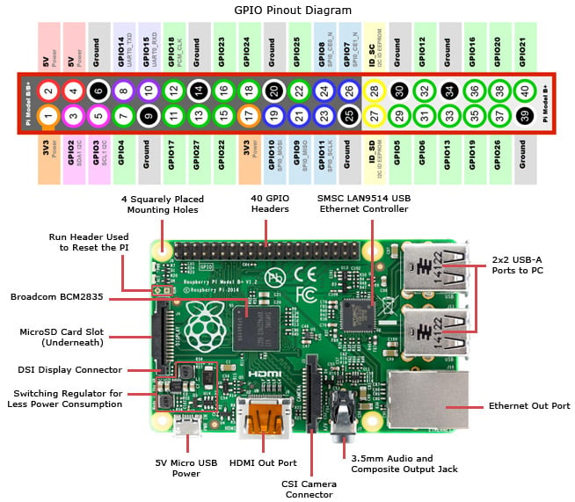

1. If everything goes well, install some lightweight IDE like VSCode on berry to perform a bit of Python coding <https://code.visualstudio.com/docs/setup/raspberry-pi>. Or use a simple pre-installed Thonny. Download Git for version control.
2. Install packages *picamera2* [*https://pypi.org/project/picamera2/*](https://pypi.org/project/picamera2/)for camera manipulation and *Adafruit-DHT* [*https://pypi.org/project/Adafruit-DHT/*](https://pypi.org/project/Adafruit-DHT/)for DHT sensor manipulation. You might encounter the error *externally-managed-environment*, which can be solved via:
   1. *pip install picamera2 --break-system-packages.* Not recommended but easy to use
   2. creating a separate python environment (e.g. Pipenv <https://pipenv.pypa.io/en/latest/> )
3. Test picamera with the following piece of code. Debug if needed

*import picamera2*

*camera = picamera2.Picamera2()*

*camera.start()*

*camera.capture_file(image_path)*

1. Test DHT sensor with the following piece of code. Debug if needed

*import adafruit_dht*

*import board*

*dht_device = adafruit_dht.DHT11(board.D21, use_pulseio=False) #Choose your board*

*temperature = dht_device.temperature*

*humidity = dht_device.humidity*

1. If everything goes well, create a full code snippet which makes the photos and temp/hum measurements on a regular basis and saves in the corresponding files/folders. Consult the official documentation on picamera2 setup in order to make sure that
   1. Picture are of the highest resolution

*config = camera.create_still_configuration()*

*camera.configure(config)*

* 1. Focus of the camera is set up correctly

*camera.set_controls({"AfMode": controls.AfModeEnum.Manual, "LensPosition": 0.01})*

[https://datasheets.raspberrypi.com/camera/picamera2-manual.pdf?_gl=1*1v5hcyc*_ga*MTU3NTU3MDQ1OC4xNzE0NzQ0MTc0*_ga_22FD70LWDS*MTcxODU0MDQ3OS42LjAuMTcxODU0MDQ3OS4wLjAuMA](https://datasheets.raspberrypi.com/camera/picamera2-manual.pdf?_gl=1*1v5hcyc*_ga*MTU3NTU3MDQ1OC4xNzE0NzQ0MTc0*_ga_22FD70LWDS*MTcxODU0MDQ3OS42LjAuMTcxODU0MDQ3OS4wLjAuMA)..

1. Save the script and now create a service which will run on the background each time the computer turns on so that if you have problems with electricity when you berry starts automatically the script is still running. You need to make sure your script when running will have access to the same Python environment as your user by adding

[Service]

User=berry

Environment="PYTHONPATH=/usr/local/lib/python3.7/site-packages"

<https://gist.github.com/emxsys/a507f3cad928e66f6410e7ac28e2990f>

1. Once you make the changes in your python file you just need to run

*sudo systemctl daemon-reload*

*sudo systemctl restart hello.service*

To update the running service with the latest code. If you want to debug the Application don’t forget to stop the service which uses the execution of your script by

*sudo systemctl stop hello.service*

Make sure your service is running correctly

*sudo systemctl status hello.service*

1. To load the resulting files from the Berry install WinSCP and via user interface just drag and drop the necessary files.